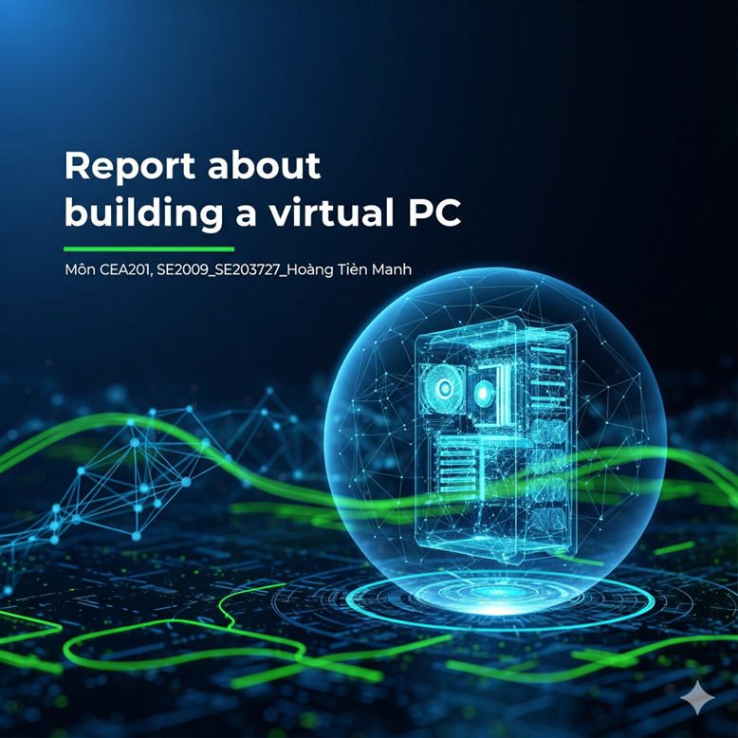

Hoang Tien Manh

Manhhoangvipbao@gmail.com

Abstract

In the era of strong information technology development as today, personal computers (PCs) play an essential role in most learning, working and data management activities. A good pc for efficient cost, energy and performance always is the best choice, I will instruct you for building a Office PC follow that.

**Building a virtual Personal Computer**

Building a basic PC for suitable on Office work.

1. Summary:
2. Overview: In the era of strong information technology development as today, personal computers (PCs) play an essential role in most learning, working and data management activities. Especially in the office environment, a computer with the right configuration will help optimize work efficiency, save investment costs and ensure long-term stability. Understanding the configurations that make up a computer as well as the ability to install a system that suits specific needs is a necessary practical skill for students majoring in information technology and computer engineering.
3. Target:

+Choose a computer configuration suitable for developer checking task and main work is office tasks such as word processing, web browsing, using accounting software and online meetings.

+Build a detailed configuration table with reasons for choosing each component based on performance criteria, compatibility and reasonable cost for current office work.

1. Requirement:

Requires a PC with the potential to perform well in the basic working. The computer must be capable, highly efficient, and energy efficient.

1. Core component of PC: Control Processer Unit, Mainboard, RAM, ROM, Power System Unit.
2. Sub-core component: Coller PC, GPU, Screen, Keyboard, Webcam, Audio Speaker, Mouse, Printer.

+Core component:

CPU – Processor: Most important!

Is the center of all tasks.

Needs to be strong enough to handle multitasking, heavy Excel, accounting software, smooth online meetings.

Recommended: Intel Core i5 or i7 generation 12 or higher (i7-12700 is too good).

RAM – Internal memory

Determining factor for smoothness when opening multiple applications

Many office users often open many Chrome + Excel + Zoom tabs → weak RAM is laggy.

Recommended: 16GB DDR4 is the gold standard. Don't stop at 8GB anymore.

SSD – Data access speed

Very important for fast booting, instant file opening

Compared to HDD, SSD speeds up the machine significantly.

Recommended: 512GB NVMe SSD. If the budget is low, using 256GB is also fine but it fills up easily.

Mainboard – Motherboard

Compatibility and connectivity are important

Should choose the type that supports multiple USB ports, Wi-Fi is good.

Recommended: Main supports DDR4, socket compatible with CPU (eg: ASROCK B760M).

+Sub-core component: Can pay less for save money.

Case (computer case): Does not affect performance, choose a compact, easy-to-install type

Power supply (PSU): Does not need high capacity, just need 500–550W and a reputable brand

GPU (discrete graphics card): Not necessary because the i7 CPU has an integrated GPU that is enough for office use

Peripherals (mouse, keyboard): Use a popular, durable type – no gaming needed

Steps-to-Step for building a virtual PC on Internet.

Step 1: Log in to this website: <https://pcpartpicker.com/>

If you have an account, click login, if you don't, click register

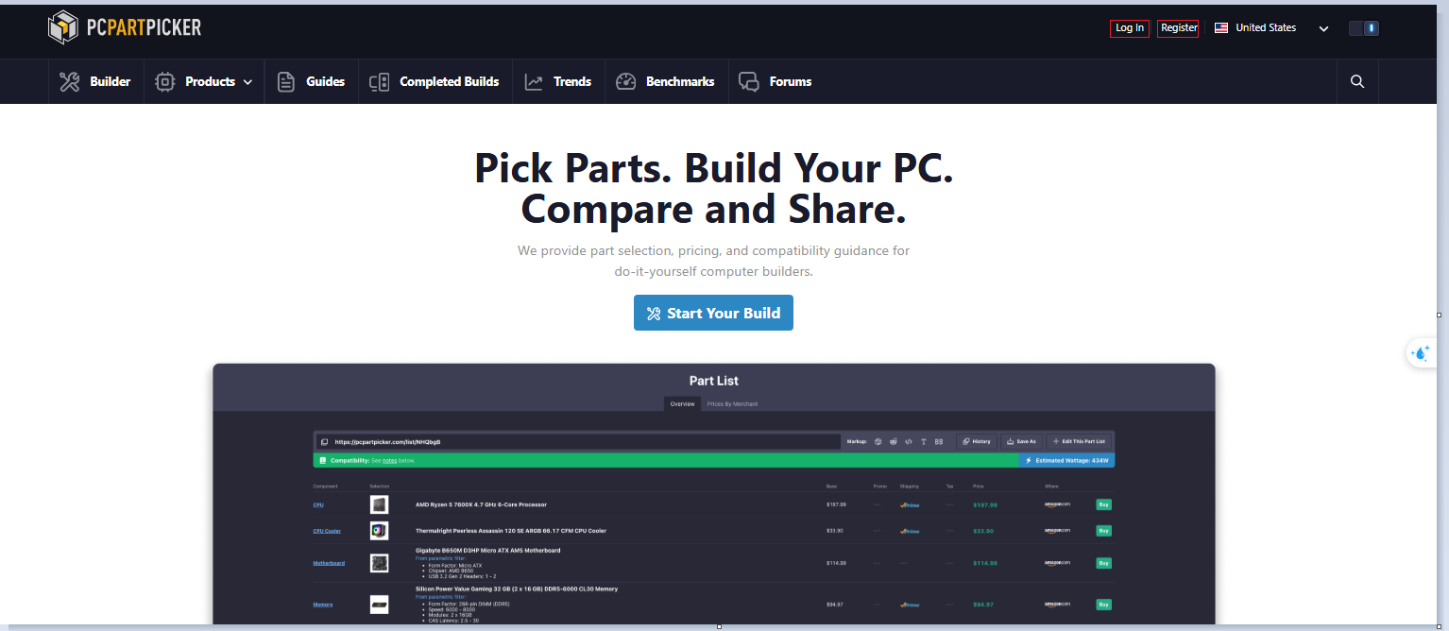

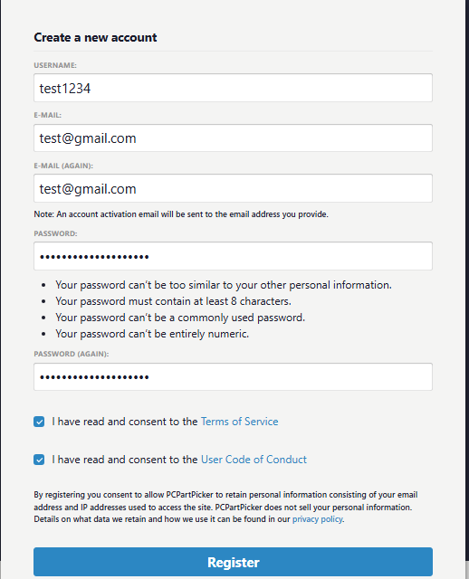

Fill in the information in the form and click register

Step 2: Click start your build to begin:

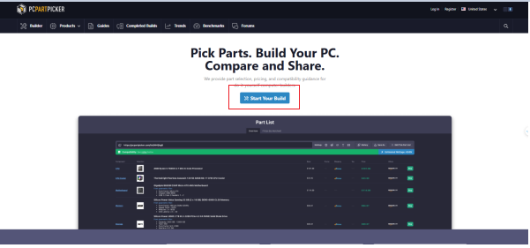

- After clicking, an interface like this will appear to help choose the components of the PC

- Click choose a ... to choose the component

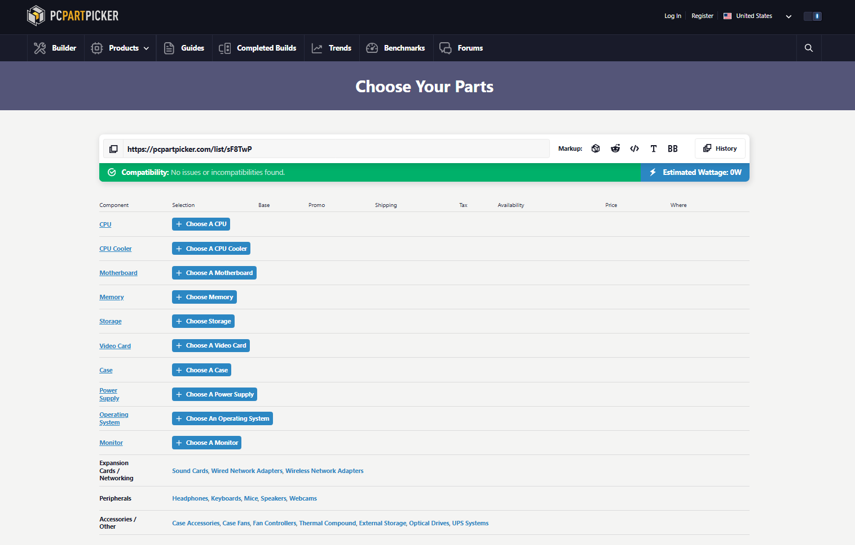



Example:

Component (Indicates what this is): CPU

Selection (Indicates which type to choose): AMD Ryzen 7 9800X3D 4.7 GHz 8-core processor

Base (Price): $451.50

Promo (Current promotions): none

Shipping (Shipping): Prime (free or fast from Amazon Prime)

Tax (Tax): unknown

Availability (Availability): in stock

Final price (Price): $451.50

Where to buy (where): amazon dot com

Buy button: Buy

*If you press buy bottom you can transfer to amazon.com to get components.*

* If amazon or some e-commerce site do not have it, you can buy it on Google.

#Selecting Components:

Selecting components for an office computer should be based on three main criteria: suitable performance, reasonable cost, and future upgradeability. Based on those criteria, I selected the following components:

Control Processer Unit

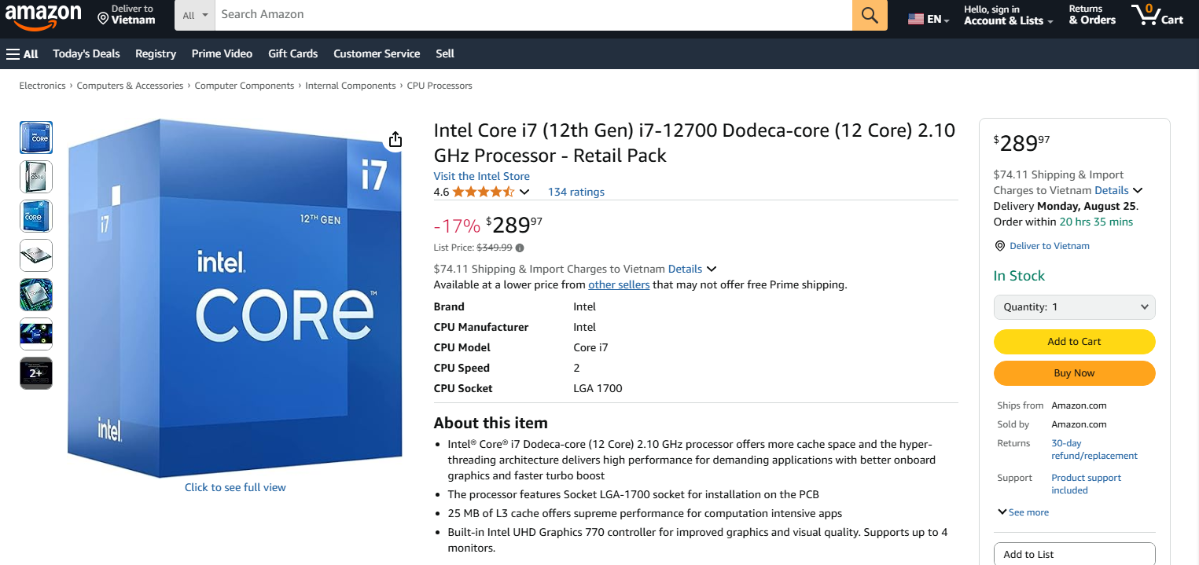

● Reasons to choose: Intel Core i7-12700 CPU has strong performance with 12 cores (8 performance cores + 4 power-saving cores) and a clock speed of up to 4.9GHz, very suitable for handling modern office tasks such as multitasking, online meetings, processing large spreadsheets or heavy accounting software.

● Using Intel Core i7-12700 CPU includes an integrated GPU → no need to buy a separate GPU -> Save costs

● In addition, this CPU also supports new technologies such as Intel Thread Director, which helps optimize processing threads when multitasking.

Mainboard – ASROCK B760M PRO RS Wifi DDR4

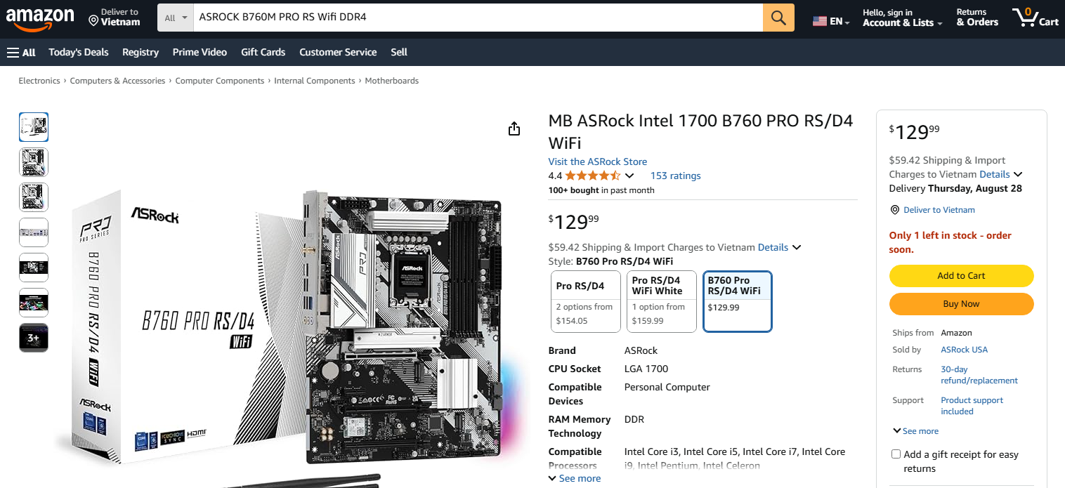

● Reasons to choose: This motherboard is fully compatible with 12th generation Intel CPUs, supports DDR4 RAM to save costs compared to DDR5.

● Built-in Wi-Fi makes it easy to connect to the network without having to buy an additional network card, and has many expansion ports (USB 3.2, M.2 NVMe, HDMI, etc.), making it flexible to use.

RAM – KingSpec 16GB DDR4 3200MHz

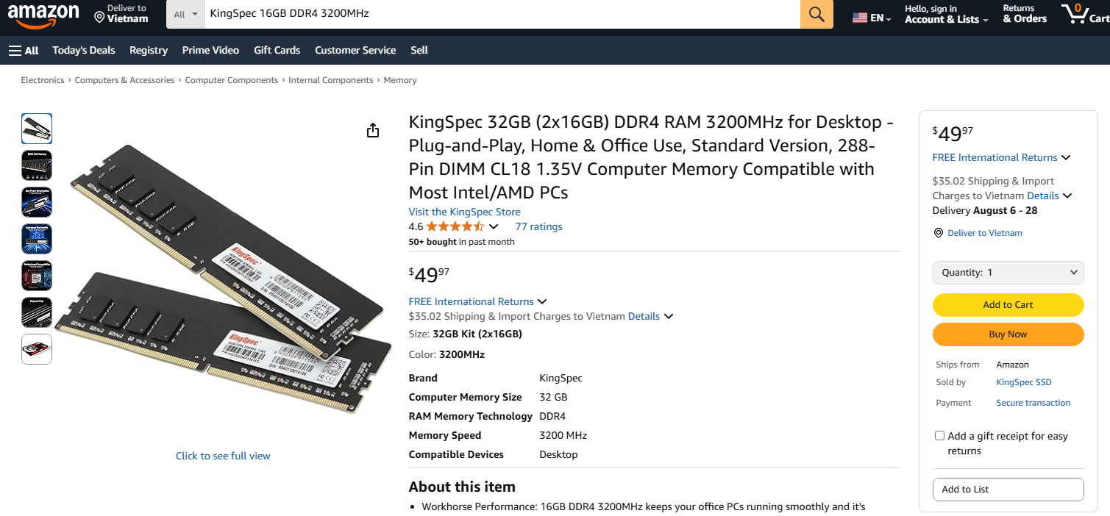

● Reason for choosing: 16GB capacity is the current optimal standard for office machines, allowing multiple applications to be opened simultaneously without delay.

● DDR4 3200MHz RAM helps increase data retrieval speed, compatible with the selected mainboard and CPU.

Stronge – SSD Patriot P300 512GB M.2 NVMe

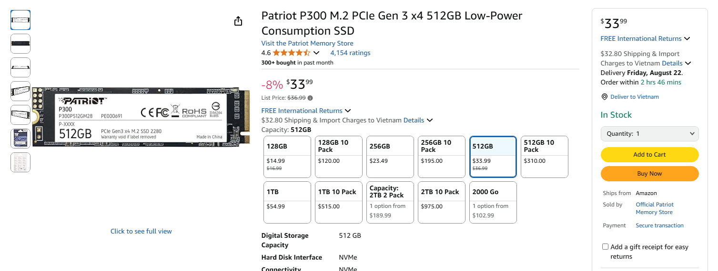

● Reasons to choose: M.2 NVMe SSD standard has superior read/write speed compared to HDD, helping the computer boot up quickly, opening applications in just a few seconds.

● 512GB capacity is enough for the operating system, office software and personal data storage without needing an additional hard drive.

PSU– Antec META V550 (550W)

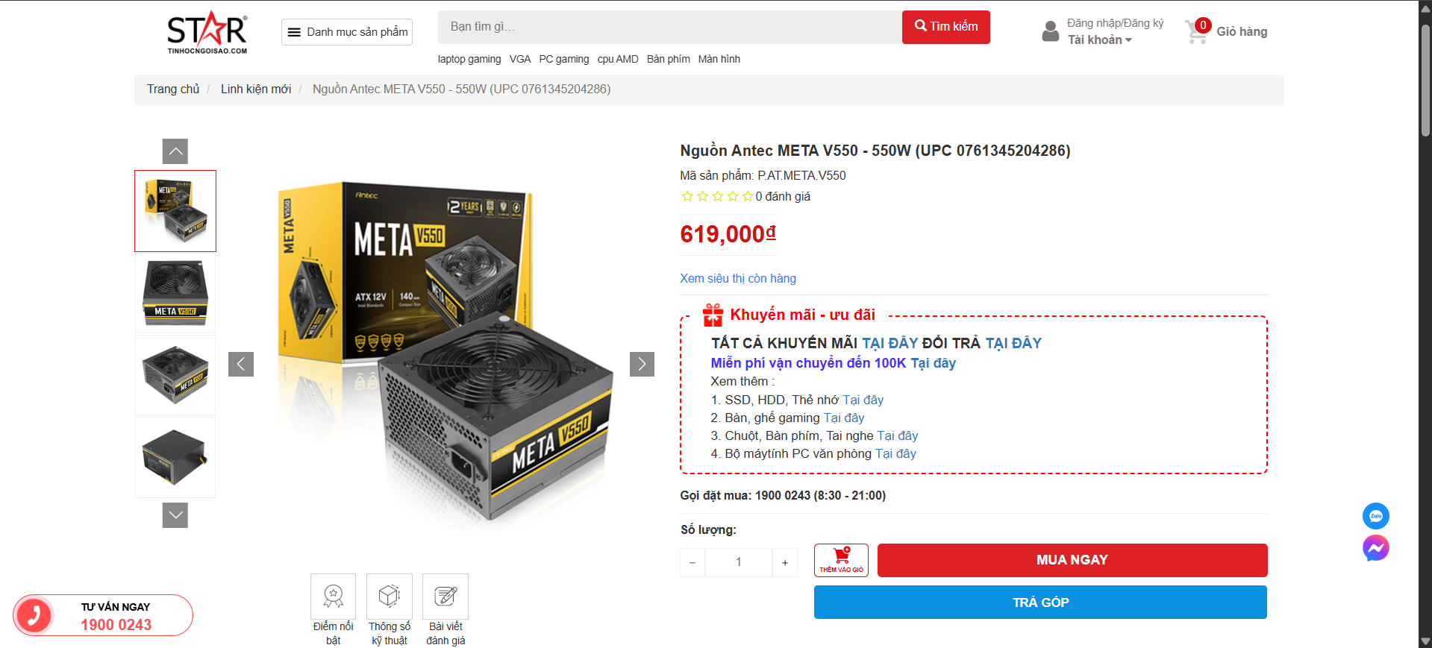

● Reason for choosing: 550W capacity is enough to operate the system stably, and has extra capacity if you want to upgrade the graphics card or add a hard drive later.

● Antec is a reputable brand, the power source meets real capacity standards, helping to protect other components from voltage risks.

Case – VSP V600

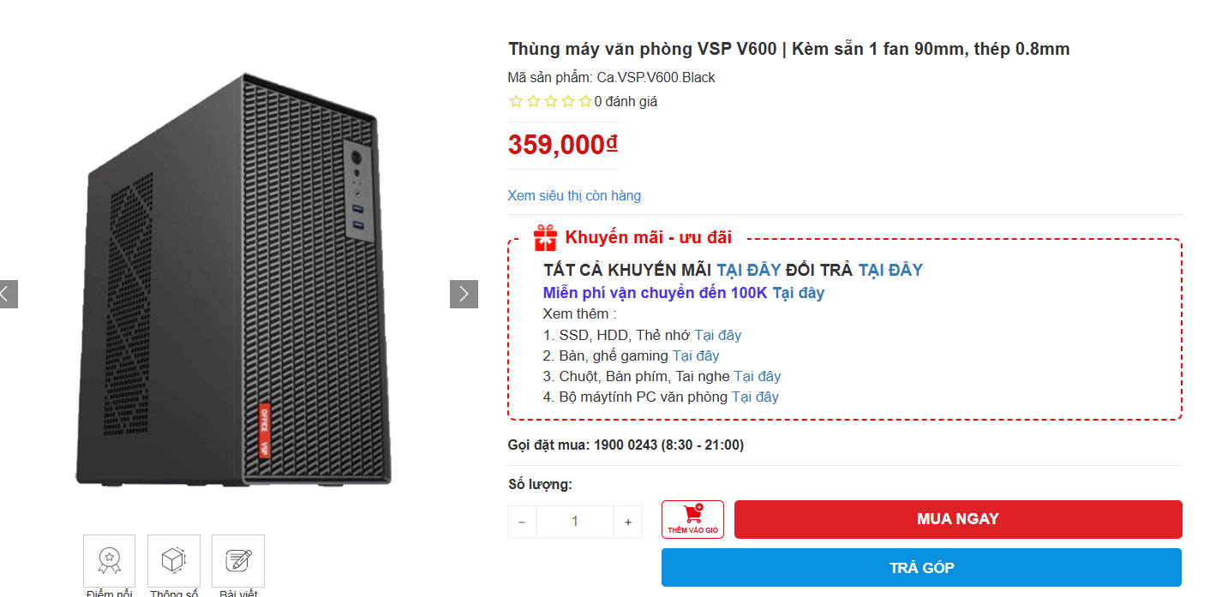

● Reason for choosing: The case has a compact design, suitable for office space. 0.8mm thick steel material creates sturdiness and aesthetics.

Sub-components - estimated total

In addition to the main components inside the case, for the computer to operate fully in an office environment, it is necessary to equip some additional peripherals:

ViewSonic VA2432-H 24 inch IPS Full HD monitor Displays images, supports clear work with IPS panel ~2,300,000

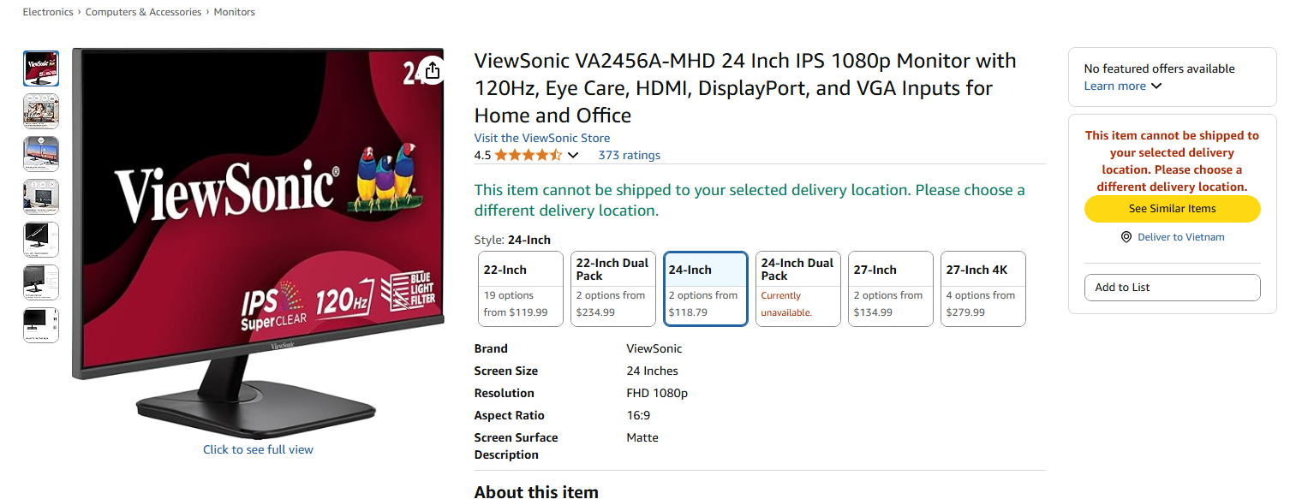

Logitech K120 USB keyboard Data entry, durable design, reasonable price ~250,000

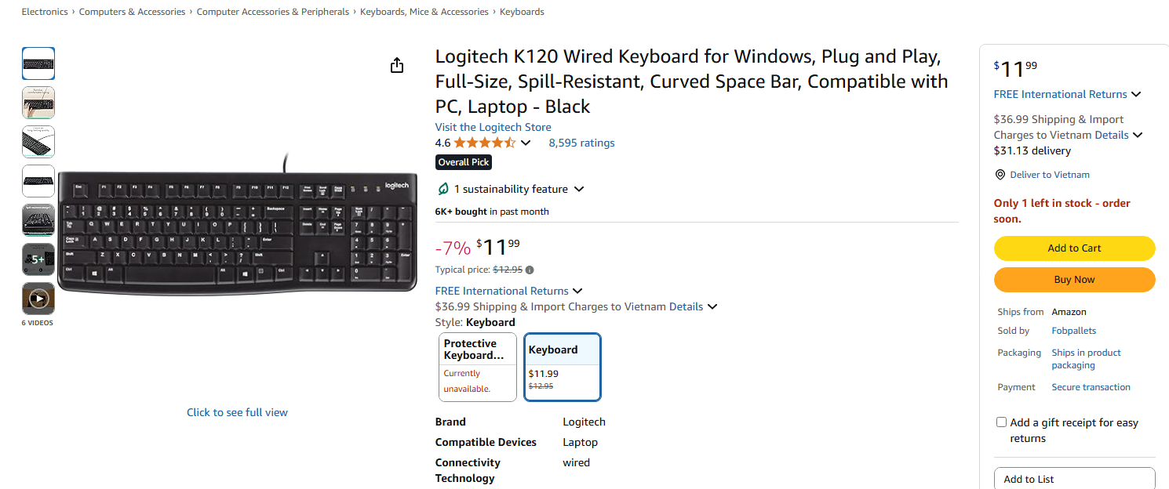

Logitech M100r USB mouse Flexible mouse movement and control ~180,000

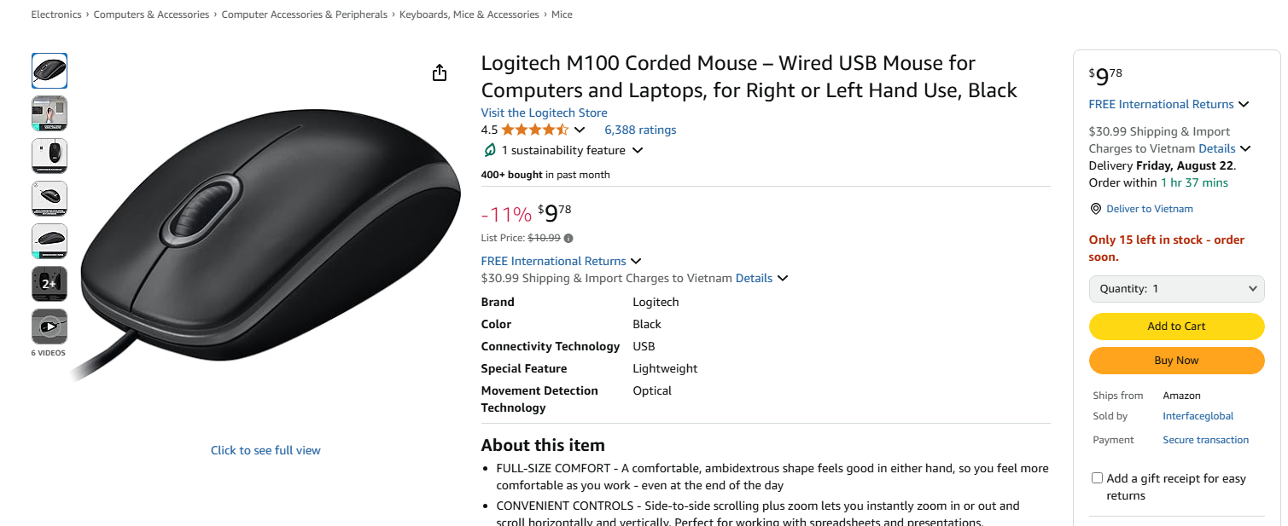

Headphones (if needed for meetings) DareU EH469 or equivalent Online meetings, ensuring clear sound and quality microphone ~300,000



Power splitter + power cord 4-5 socket type, with safety switch Safe power connection for the entire device ~150,000

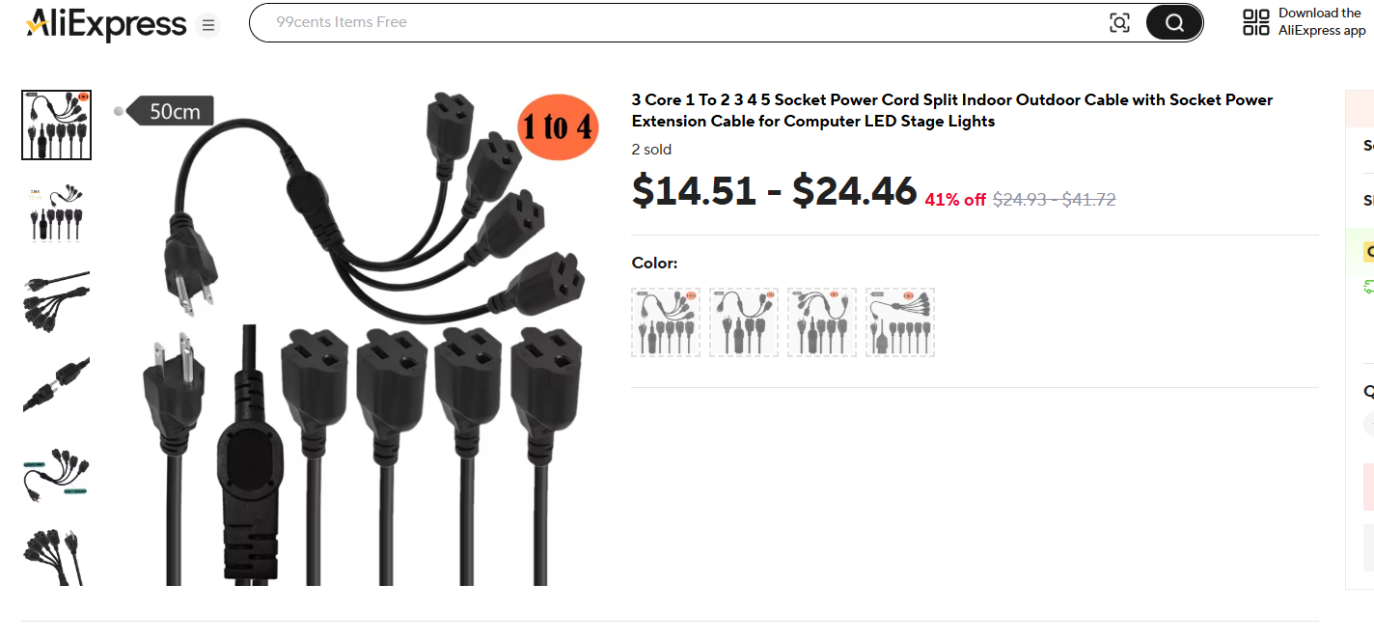

Webcam (if needed) Hikvision DS-U02 Online meeting, clear image ~400,000

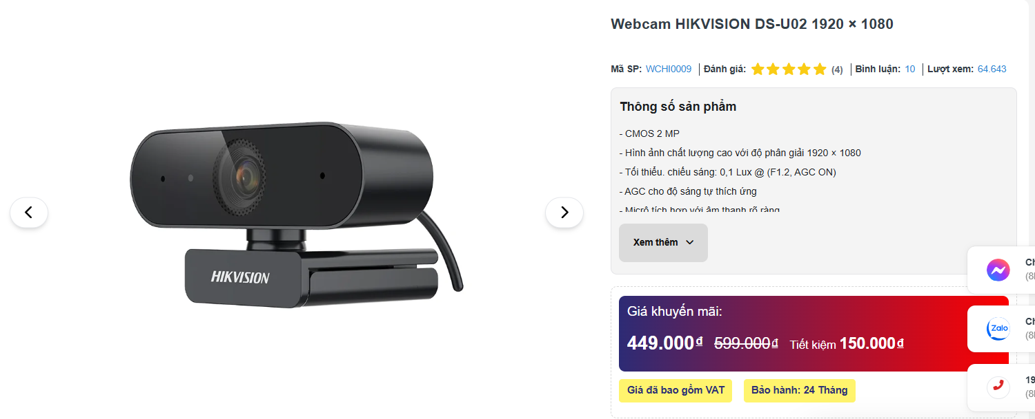

➤ Total estimated cost for peripheral components: ~3,580,000 VND

➤ Total cost of the entire system (components in the case + peripherals):

→ PC: ~11,700,000 VND + Peripherals: ~3,580,000 VND = Total: ~15,280,000 VND

**Suggested Component Upgrades to Boost Performance**

Depending on specific work requirements and the user's budget, some components can be replaced or upgraded to increase processing speed, improve multitasking, storage, or graphics performance. Below are some upgrade suggestions with flexible price ranges:

| Component | Upgrade Option | Advantages | Estimated Price (VND) |
| --- | --- | --- | --- |
| **CPU** | Intel Core i7-13700 / i9-13900 | More cores and threads → faster processing for heavy tasks, better multitasking | ~9,000,000 – 14,000,000 |
| **RAM** | 32GB (2x16GB DDR4 3200MHz) | Excellent for multitasking, running multiple applications simultaneously without lag | ~1,300,000 – 1,800,000 |
| **SSD** | 1TB M.2 NVMe (Samsung 980 / WD Black) | Increases access speed, stores more data, allows installation of more software | ~1,500,000 – 2,800,000 |
| **Power Supply (PSU)** | 650W – 750W (80 Plus Bronze/Gold) | Provides good headroom for future upgrades of the graphics card and storage drives | ~1,200,000 – 2,000,000 |
| **Graphics Card (GPU)** | NVIDIA GTX 1650 / RTX 3050 / RTX 4060 | Supports graphic design, video editing, gaming, or basic AI tasks | ~3,000,000 – 9,000,000 |
| **Mainboard** | B760 or Z690 supporting DDR5 RAM | Increases future upgrade potential (new RAM standard, more expansion slots) |  |

**Note:** Upgrades require checking for component compatibility, especially between the CPU, mainboard, RAM, and PSU. Additionally, when upgrading to a more powerful GPU or CPU, ensure the cooling system and power supply are adequate.

1. Conclusion:

+ Building an office computer requires not only a solid understanding of hardware components but also the ability to evaluate performance, cost, and suitability for real-world needs. By selecting components like an **Intel Core i7-12700 CPU**, an **ASROCK B760M motherboard**, **16GB of RAM**, a **512GB NVMe SSD**, and an appropriate power supply and case, the team has created a PC configuration that balances performance with cost-effectiveness.

+ This system fully meets the demands of a modern office, from processing documents quickly and smooth online meetings to handling accounting software and large datasets, while still allowing for future upgrades. Additionally, peripherals such as an **IPS monitor**, **Logitech keyboard and mouse**, and a headset for conferences provide a convenient and professional work experience.

+ Through this project, I have not only honed my practical skills but also gained a deeper understanding of how to optimize costs and build an efficient computer system for a practical work environment.